KS2 French
French Lesson 3: Days of the week.
Watch the BBC video on Teams / your class home learning page to hear a song about the days of the week in French. You might remember some of the days already from your French lessons in school. There is also a link to a short YouTube video to help with pronunciation.
TASK: Once you have watched the videos, complete the table below to show the missing days of the week.
See what you can do from memory, then use the word bank below to check your spellings
Challenge: use the phonetic pronunciation guide here and the clues in the video to practise saying the days of the week out loud. Bonne chance!
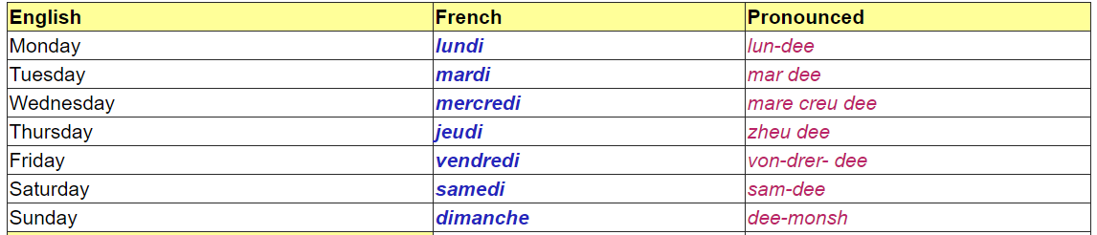

Les jours de la semaine.
The days of the week
Fill in the gaps to show the name of the day before and the day after. The first one has been done for you.
Extra challenge: What do you notice about the first letter of the days of the week in French, compared to English?
hier  yesterday | aujourd’hui  today | demain  tomorrow
mardi | mercredi  (Wednesday) | jeudi
 | vendredi
 | dimanche
 | samedi
 | mardi
 | jeudi
 | lundi

